Phillips Curve 1
Which of the following best describes the relationship that the short-run Phillips curve (SRPC) illustrates?
- the trade-off between liquidity and earning interest
- The maximum sustainable amount of production in an economy
- the natural rate of unemployment is independent of changes in the inflation rate
- The full employment output is independent of changes in the price level
- the trade-off between unemployment and inflation

2
Assume the current rate of unemployment is 9% and the natural rate of unemployment is 5%. The expected rate of inflation is 4%.
Which of the following correctly illustrates the current state of the economy using long-run and short-run Phillips curves?
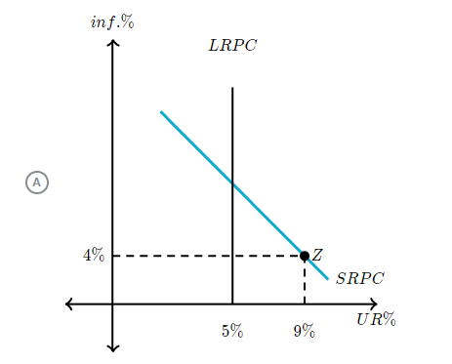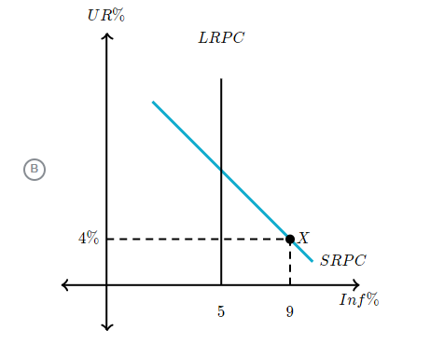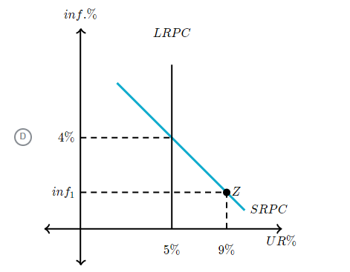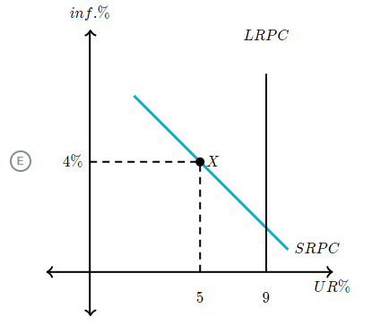

3
The Hamsterville government recently engaged in contractionary fiscal policy.
Which of the following Phillips curve models correctly illustrates the short-run impact of contractionary fiscal policy?
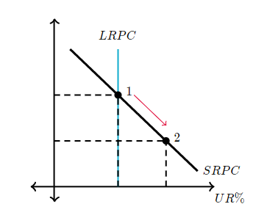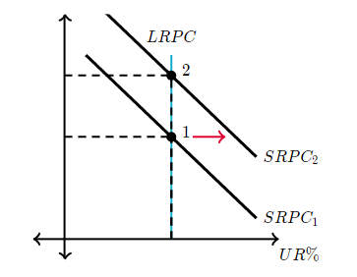
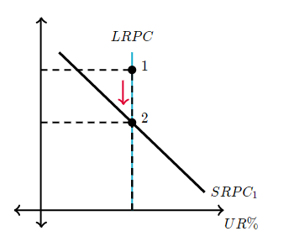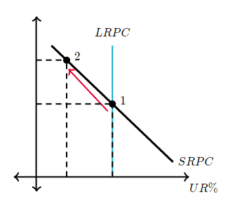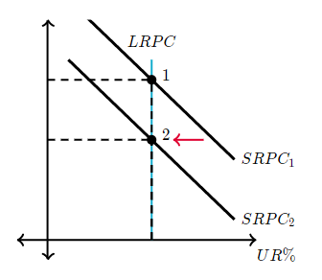

4
The current state of the economy of Te Rehunga is represented in the graph shown here:
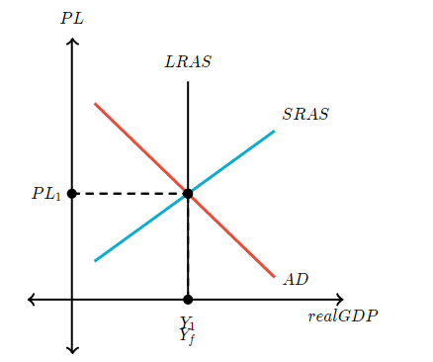
Let point B in the options below represent the current combination of inflation and the unemployment rate.
Which of the following graphs best depicts the Phillips curve model of Te Rehunga based on this AD-AS model?
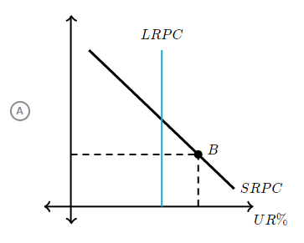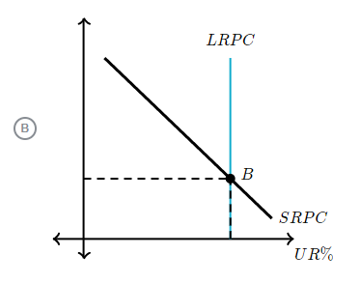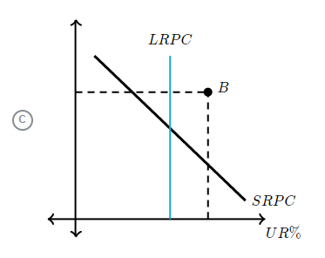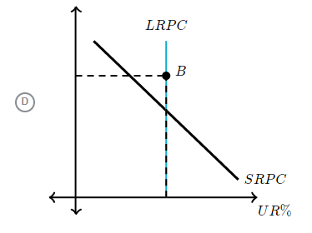

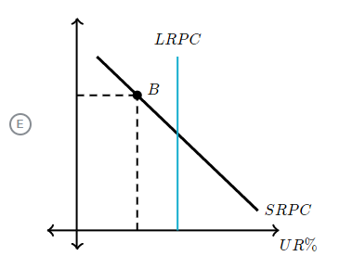

5
Which of the following represents how a positive aggregate demand shock would impact the Phillips curve model?
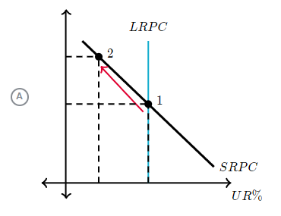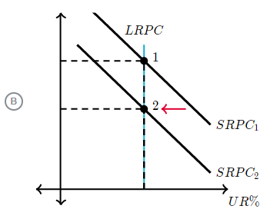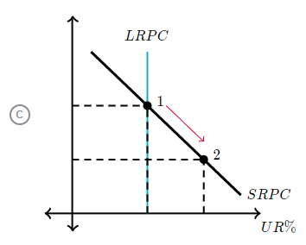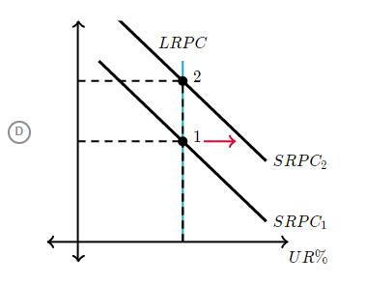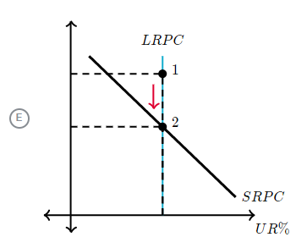

6
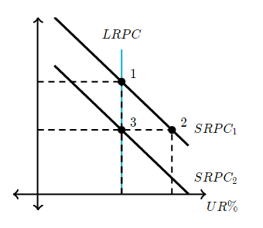
In the graph of the Phillips curve shown here, an economy moved from point 1 to point 2 to point 3.
Which of the following would best represent the movement from point 2 to point 3 shown in the graph?
- An increase in short-run aggregate supply (SRAS)
- A decrease in short-run aggregate supply (SRAS)
- An increase in the natural rate of unemployment
- An increase in aggregate demand (AD)
- A decrease in aggregate demand (AD)

7
Which of the following would cause the long-run Phillips curve to shift to the right?
- An increase in structural unemployment
- An increase in aggregate demand (AD)
- An decrease in aggregate demand (AD)
- An increase in cyclical unemployment
- A decrease in frictional unemployment

8
Which of the following actions would most likely lead to a shift to the left of the short-run Phillips curve, or SRPC?
- A strong central bank commitment to reducing inflation
- A strong central bank commitment to decreasing cyclical unemployment
- A strong government commitment to engage in expansionary fiscal policy
- A strong central bank commitment to increasing the money supply
- A strong government commitment to reducing structural unemployment

Answer:
1 E
2 C
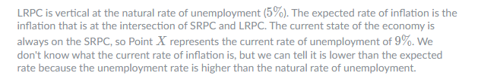
3 A
4 B
5 A
6 A
7 A
8 E

